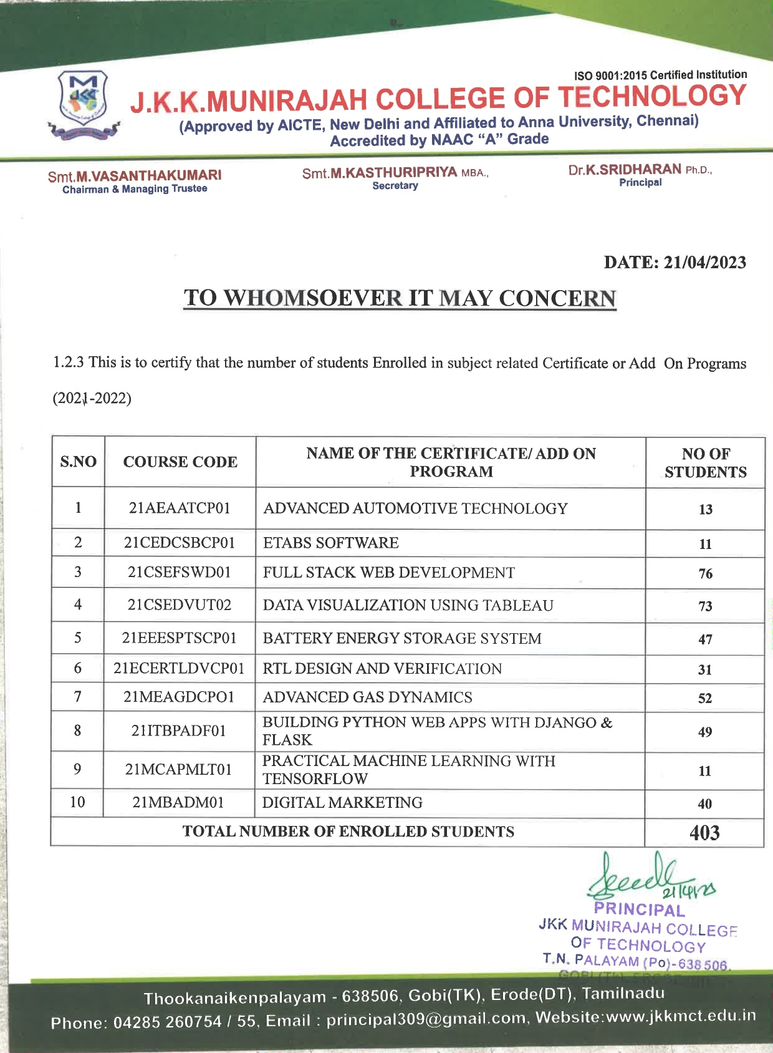



J.K.K. MUNIRAJAHCOLLEGE OF TECHNOLOGY
Approved by AICTE, New Delhi And Affiliated to Anna University, Chennai.
Accredited by NAAC with “A” grade
T.N. Palayam (Po), Gobi (Tk), Erode (Dt) – 638 506

1.2.3 List of students enrolled for Add on /Certificate Programs offered through the last Academic year 2021-2022

SI.NO | NAME OF THE CERTIFICATE/ ADD ON PROGRAM | PAGE NO | LINK TO THE RELEVANT DOCUMENT
1 | ADVANCED AUTOMOTIVE TECHNOLOGY | 01-13 | CLICK HERE
2 | ETABS SOFTWARE | 14-25 | CLICK HERE
3 | FULL STACK WEB DEVELOPMENT | 26-102 | CLICK HERE
4 | DATA VISUALIZATION USING TABLEAU | 103-178 | CLICK HERE
5 | BATTERY ENERGY STORAGE SYSTEM | 179-226 | CLICK HERE
6 | RTL DESIGN AND VERIFICATION | 227-256 | CLICK HERE
7 | ADVANCED GAS DYNAMICS | 257-303 | CLICK HERE
8 | BUILDING PYTHON WEB APPS WITH DJANGO & FLASK | 304-355 | CLICK HERE
9 | PRACTICAL MACHINE LEARNING WITH TENSORFLOW | 356-368 | CLICK HERE
10 | DIGITAL MARKETING | 367-403 | CLICK HERE

