
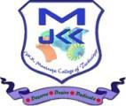
J.K.K.MUNIRAJAHCOLLEGEOFTECHNOLOGY
Approved by AICTE, New Delhi and Affiliated to Anna University, Chennai.

T.N.Palayam (Po),Gobi (Tk),Erode(Dt)–638506

2.3.2 Teachers use ICT enabled tools for effective teaching-learning process

NOTE: The supporting documents for this metric exceed the uploading limit of 5 MB. Hence the supporting documents are made available in HEI website and the links for the metric is given below.

S.NO. | DESCRIPTION | LINK TO VIEW DOCUMENT
1 | 2.3.2 Teachers use ICT enabled tools for effective teaching-learning process. | CLICK HERE

