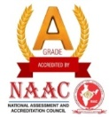
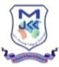
J.K.K. MUNIRAJAH COLLEGE OF TECHNOLOGY
(AUTONOMOUS)
Approved by AICTE, New Delhi And Affiliated to Anna University, Chennai.
Accredited by NAAC with “A” grade
T.N. Palayam (Po), Gobi (Tk), Erode (Dt) – 638 506
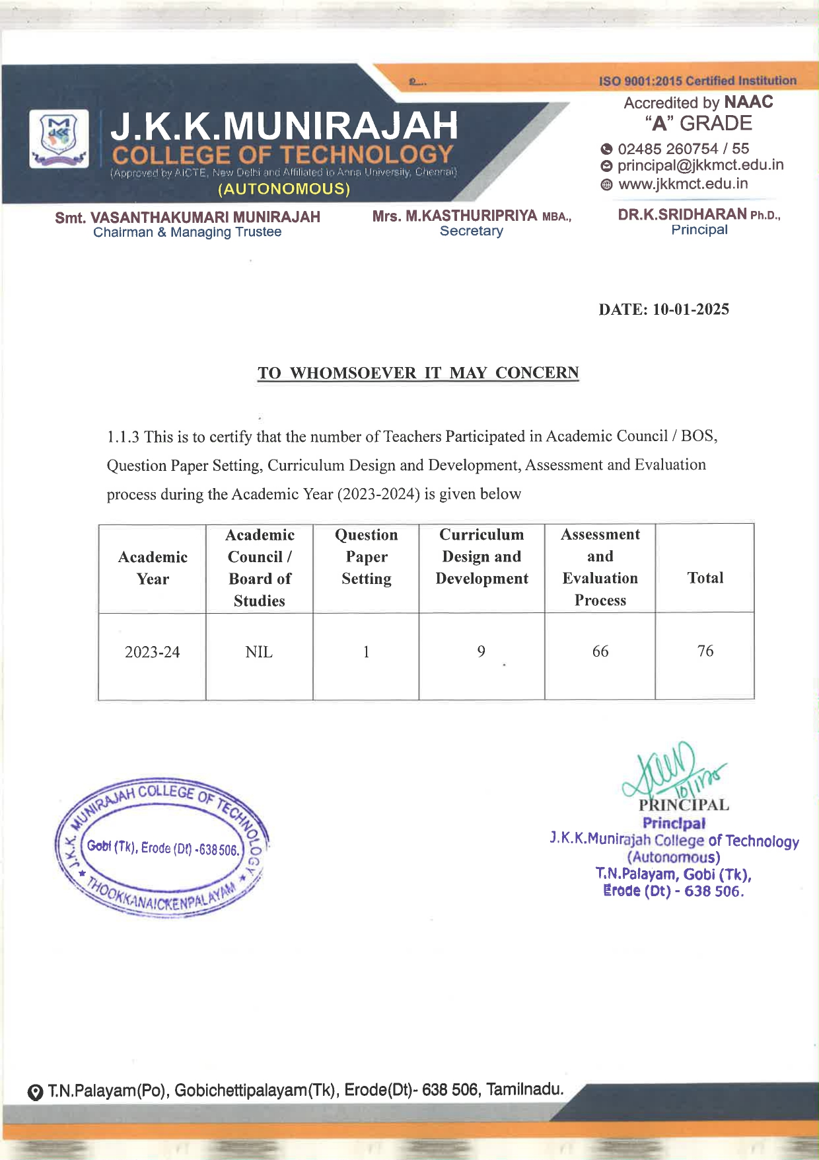

J.K.K. MUNIRAJAH COLLEGE OF TECHNOLOGY
(AUTONOMOUS)
Approved by AICTE, New Delhi And Affiliated to Anna University, Chennai.
Accredited by NAAC with “A” grade
T.N. Palayam (Po), Gobi (Tk), Erode (Dt) – 638 506

1.1.3 Teachers of the Institution participate in following activities related to curriculum development and assessment of the Affiliating University and/are represented on the following academic bodies during the year 23-24.

1. Academic Council/BOS of affiliating university
2. Setting of question papers for UG/PG programs
3. Design and Development of Curriculum for Add on/ Certificate/ Diploma Courses
4. Assessment / Evaluation process of the affiliating University

S.No | Academic  Year | Description | Link to the  relevant  documents
1 | 2023-24 | Academic Council / BoS /  QP setting / Curriculum  Design / Assessment &  Evaluation | 2023-24 PAGE  CLICK HERE

