
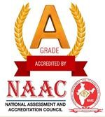
J.K.K. MUNIRAJAH COLLEGE OF TECHNOLOGY

(AUTONOMOUS)
Approved by AICTE, New Delhi And Affiliated to Anna University, Chennai.
Accredited by NAAC with “A” Grade
T.N.Palayam (Po) ,Gobi (Tk), Erode (Dt.)–638506

6.4.1.Institution Conducts Internal and Externals Financial Audits Regularly.

S. NO. | CONTENTS | LINK TO THE RELEVANT DOCUMENT
1. | Internal Financial Audits | 6.4.1.1.
2. | External Financial Audits | 6.4.1.2.

