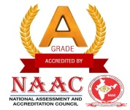

J.K.K. MUNIRAJAH COLLEGE OF TECHNOLOGY
(AUTONOMOUS)
Approved by AICTE, New Delhi And Affiliated to Anna University, Chennai.
Accredited by NAAC with “A” grade
T.N. Palayam (Po), Gobi (Tk), Erode (Dt) – 638 506

6.4.3. Institutional Strategies for Mobilization of Funds and the Optimal Utilization of Resources.

S.NO. | CONTENT | LINK TO THE RELEVANT DOCUMENT
1. | Resource mobilization policy document  With procedures | 6.4.3.1
2. | Income and expenditure account  statement | 6.4.3.2
3. | Fee-receipt | 6.4.3.3
4. | College brochure on the fee information | 6.4.3.4

