
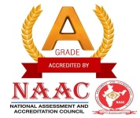
J.K.K. MUNIRAJAH COLLEGE OF TECHNOLOGY
(AUTONOMOUS)
Approved by AICTE, New Delhi And Affiliated to Anna University, Chennai.
Accredited by NAAC with “A” grade
T.N. Palayam (Po), Gobi (Tk), Erode (Dt) – 638 506

6.5.1. Internal Quality Assurance Cell (IQAC) has contributed significantly for institutionalizing the quality assurance strategies and processes.

SL. NO. | PARTICULARS | LINKTOTHERELEVANT DOCUMENT
1 | Value Added Courses | 6.5.1.1
2 | Faculty Development Programs | 6.5.1.2

